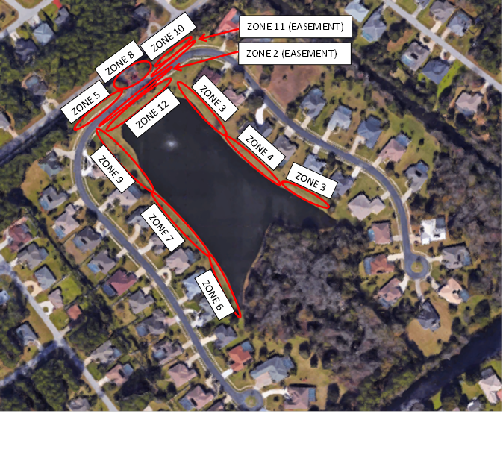

|  |  |  |
| --- | --- | --- |
| ZONE | ROTATORS | POPUPS |
| 1 | not used | |
| 2 | 0 | 21 |
| 3 | 13 | 0 |
| 4 | 8 | 0 |
| 5 | 0 | 20 |
| 6 | 7 | 0 |
| 7 | 8 | 0 |
| 8 | 0 | 14 |
| 9 | 12 | 0 |
| 10 | 0 | 12 |
| 11 | 0 | 12 |
| 12 | 0 | 13 |
| 13 | not used | |
| 14 | not used | |
| 15 | not used | |
| 16 | not used | |